SQL Date Data Types

**MySQL** comes with the following data types for storing a date or a date/time value in the database:

● DATE - format YYYY-MM-DD

● DATETIME - format: YYYY-MM-DD HH:MI:SS

● TIMESTAMP - format: YYYY-MM-DD HH:MI:SS

● YEAR - format YYYY or YY

**SQL Server** comes with the following data types for storing a date or a date/time value in the database:

● DATE - format YYYY-MM-DD

● DATETIME - format: YYYY-MM-DD HH:MI:SS

● SMALLDATETIME - format: YYYY-MM-DD HH:MI:SS

● TIMESTAMP - format: a unique number

Note: The date datatypes are chosen for a column when you create a new table in your database!

SQL Working with Dates

You need to create table,or alter table with date attribute.

Following is the query sample to use **date datatype**

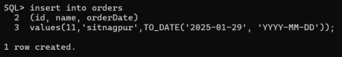

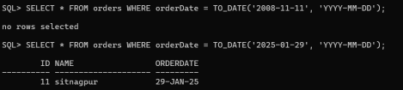Look at the following table:

Orders Table

**OrderId ProductName OrderDate** 1 Geitost 2008-11-11 2 Camembert Pierrot 2008-11-09 3 Mozzarella di Giovanni 2008-11-11

4 Mascarpone Fabioli 2008-10-29

Now we want to select the records with an OrderDate of "2008-11-11" from the table above.

We use the following SELECT statement:

SELECT * FROM Orders WHERE OrderDate='2008-11-11'

The result-set will look like this:

**OrderId ProductName OrderDate** 1 Geitost 2008-11-11

3 Mozzarella di Giovanni 2008-11-11

Note: Two dates can easily be compared if there is no time component involved! Now, assume that the "Orders" table looks like this (notice the added time-component in the "OrderDate" column):

**OrderId ProductName OrderDate** 1 Geitost 2008-11-11 13:23:44 2 Camembert Pierrot 2008-11-09 15:45:21

3 Mozzarella di Giovanni 2008-11-11 11:12:01

4 Mascarpone Fabioli 2008-10-29 14:56:59

If we use the same SELECT statement as above:

SELECT * FROM Orders WHERE OrderDate='2008-11-11'

we will get no result! This is because the query is looking only for dates with no time portion.

**Date Functions Samples for you to execute with all possible types:**

**1. ORACLE SQL (SQLPLUS) Date Functions**

**1.1 Getting the Current Date and Time**

SELECT SYSDATE FROM dual; -- Returns the current date and time SELECT SYSTIMESTAMP FROM dual; -- Returns the current date and timestamp (including fractional seconds and time zone) 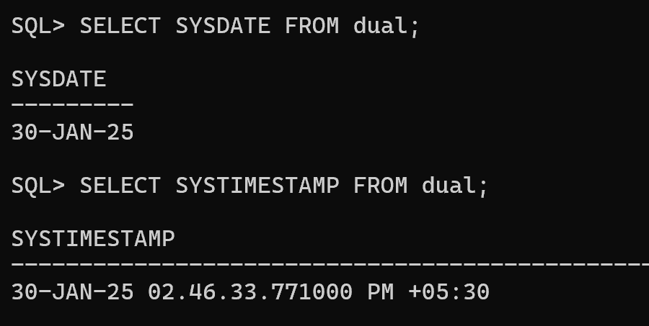

**1.2 Formatting Dates (TO_CHAR)**

SELECT TO_CHAR(SYSDATE, 'YYYY-MM-DD HH24:MI:SS') FROM dual; -- Format date as string

SELECT TO_CHAR(SYSDATE, 'DD-MON-YYYY') FROM dual; -- Example: 29-JAN-2025

SELECT TO_CHAR(SYSDATE, 'Day, Month DD, YYYY') FROM dual; -- Example: Tuesday, January 29, 2025 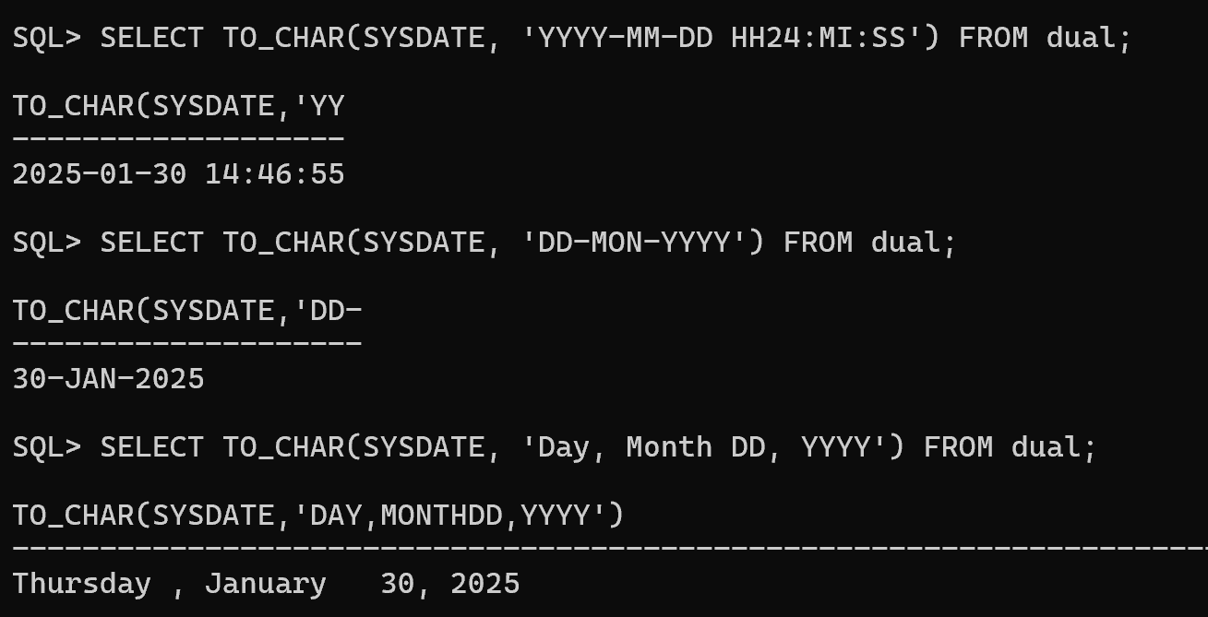

**1.3 Converting Strings to Dates (TO_DATE)**

SELECT TO_DATE('2025-01-29', 'YYYY-MM-DD') FROM dual; -- Convert string to date

SELECT TO_DATE('29-JAN-25', 'DD-MON-RR') FROM dual; -- Uses RR format for 2-digit year 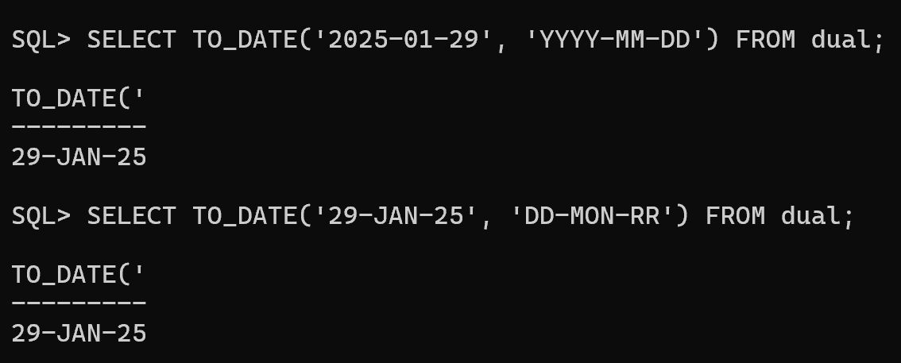

**1.4 Date Arithmetic**

SELECT SYSDATE + 7 FROM dual; -- Adds 7 days

SELECT SYSDATE - 7 FROM dual; -- Subtracts 7 days

SELECT SYSDATE + INTERVAL '2' MONTH FROM dual; -- Adds 2 months SELECT SYSDATE + INTERVAL '5' YEAR FROM dual; -- Adds 5 years 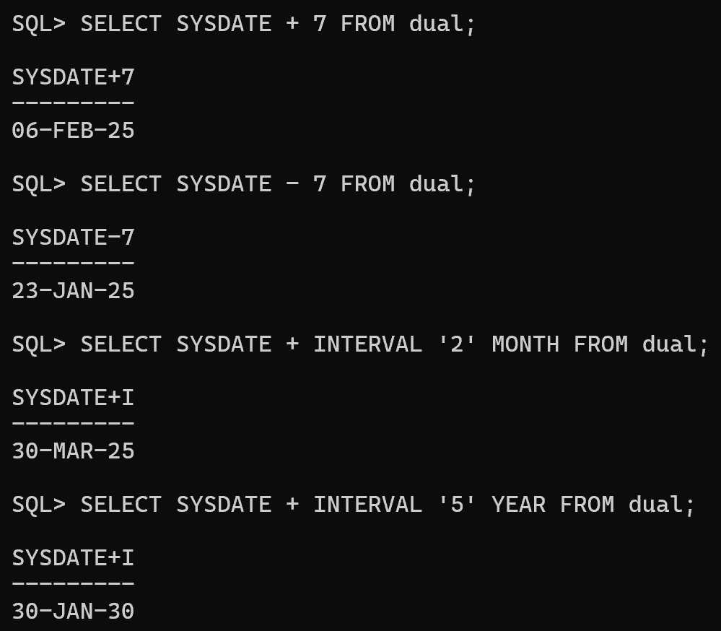

**1.5 Extracting Date Parts**

SELECT EXTRACT(YEAR FROM SYSDATE) FROM dual; -- Returns year SELECT EXTRACT(MONTH FROM SYSDATE) FROM dual; -- Returns month SELECT EXTRACT(DAY FROM SYSDATE) FROM dual; -- Returns day 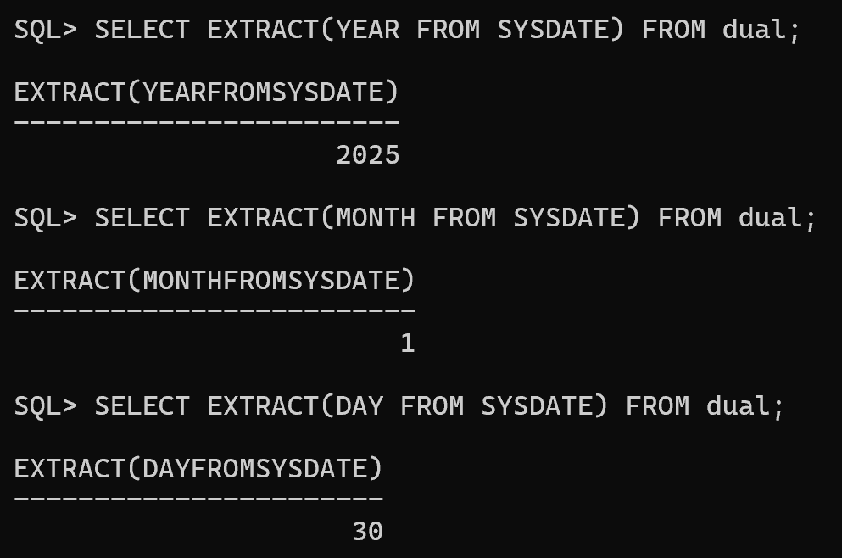

**1.6 Finding the First and Last Day of the Month**

SELECT TRUNC(SYSDATE, 'MM') FROM dual; -- First day of the current month

SELECT LAST_DAY(SYSDATE) FROM dual; -- Last day of the current month 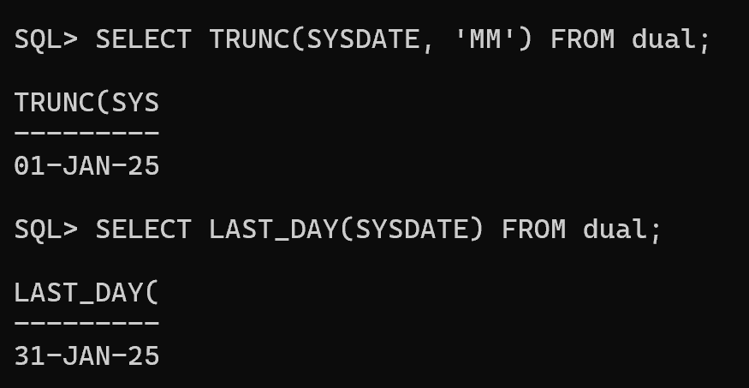**1.7 Difference Between Two Dates (MONTHS_BETWEEN)**

SELECT MONTHS_BETWEEN(TO_DATE('2025-12-31', 'YYYY-MM-DD'), SYSDATE) FROM dual; -- Returns the difference in months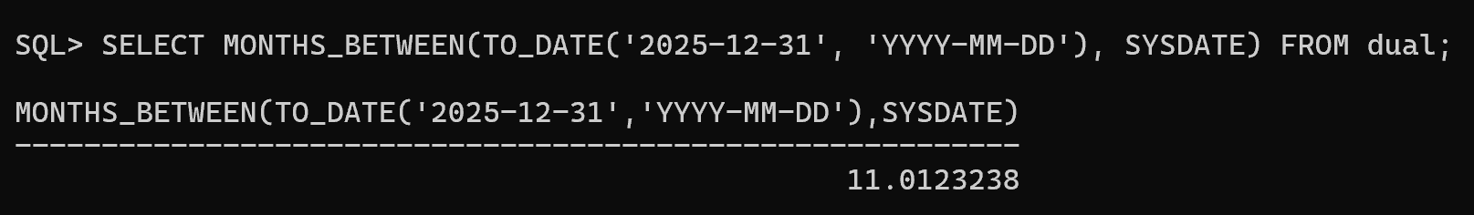

**1.8 Adding Time Components**

SELECT SYSTIMESTAMP + INTERVAL '5' HOUR FROM dual; -- Adds 5 hours SELECT SYSTIMESTAMP + INTERVAL '30' MINUTE FROM dual; -- Adds 30 minutes

SELECT SYSTIMESTAMP + INTERVAL '10' SECOND FROM dual; -- Adds 10 seconds 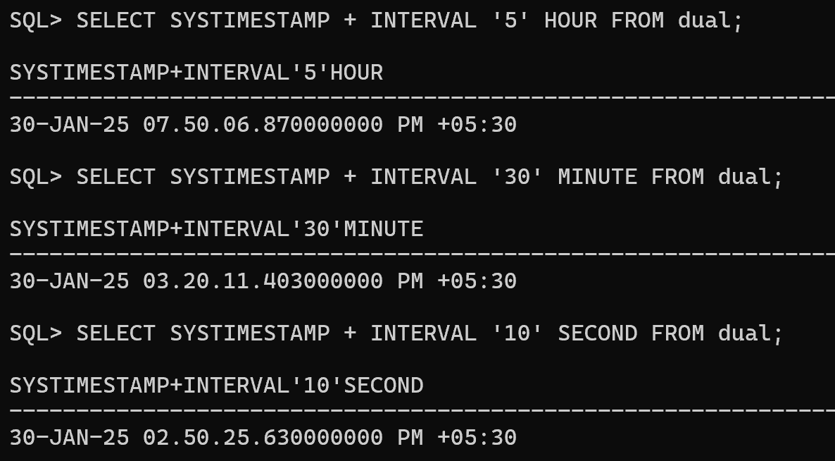

**2. MySQL Date Functions**

**2.1 Getting the Current Date and Time**

SELECT NOW(); -- Current date and time

SELECT CURDATE(); -- Current date only

SELECT CURTIME(); -- Current time only

**2.2 Formatting Dates (DATE_FORMAT)**

SELECT DATE_FORMAT(NOW(), '%Y-%m-%d %H:%i:%s'); -- Example: 2025-01-29 14:30:00

SELECT DATE_FORMAT(NOW(), '%W, %M %d, %Y'); -- Example: Tuesday, January 29, 2025

**2.3 Converting Strings to Dates (STR_TO_DATE)**

SELECT STR_TO_DATE('29-01-2025', '%d-%m-%Y'); -- Convert string to date

SELECT STR_TO_DATE('2025-01-29 14:30:00', '%Y-%m-%d %H:%i:%s'); -- Convert string to datetime

**2.4 Date Arithmetic**

SELECT NOW() + INTERVAL 7 DAY; -- Adds 7 days

SELECT NOW() - INTERVAL 7 DAY; -- Subtracts 7 days

SELECT NOW() + INTERVAL 2 MONTH; -- Adds 2 months

SELECT NOW() + INTERVAL 5 YEAR; -- Adds 5 years

**2.5 Extracting Date Parts**

SELECT YEAR(NOW()); -- Returns the current year

SELECT MONTH(NOW()); -- Returns the current month

SELECT DAY(NOW()); -- Returns the current day

**2.6 Finding the First and Last Day of the Month**

SELECT DATE_FORMAT(NOW(), '%Y-%m-01'); -- First day of the current month

SELECT LAST_DAY(NOW()); -- Last day of the current month **2.7 Difference Between Two Dates (TIMESTAMPDIFF)**

SELECT TIMESTAMPDIFF(MONTH, '2025-01-01', '2025-12-31'); -- Returns 11 months

**2.8 Adding Time Components**

SELECT NOW() + INTERVAL 5 HOUR; -- Adds 5 hours

SELECT NOW() + INTERVAL 30 MINUTE; -- Adds 30 minutes SELECT NOW() + INTERVAL 10 SECOND; -- Adds 10 seconds

**Key Differences Between SQL*Plus (Oracle) and MySQL**

|  |  |  |
| --- | --- | --- |
| **Feature** | **Oracle (SQL*Plus)** | **MySQL** |
| Current Date | SYSDATE | NOW() |
| Formatting Dates | TO_CHAR(date, 'format') | DATE_FORMAT(date, 'format') |
| String to Date  Conversion | TO_DATE(string,  'format') | STR_TO_DATE(string,  'format') |
| Date Arithmetic | SYSDATE + INTERVAL 'X' UNIT | NOW() + INTERVAL X UNIT |

Extracting Date Parts

EXTRACT(part FROM date) YEAR(), MONTH(), DAY()

First/Last Day of Month

TRUNC(SYSDATE, 'MM'), LAST_DAY(SYSDATE)

DATE_FORMAT(NOW(),

'%Y-%m-01'), LAST_DAY(NOW())